How I Made $1000 in 2 Days using the Power of Forums and Joint Ventures!

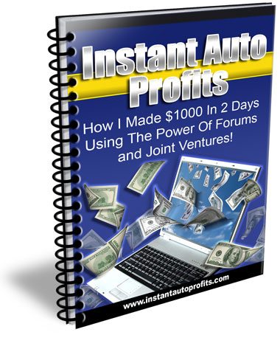

A Case Study By Robin Araoz Palmer

Dear Friend,

First of all I have to thank Willie Crawford for the excellent information he revealed in his report:

“Really Fast Money -How To Make $1000 - $2000 In 24 Hours Or Less!”



The intention of this report is not to replace the information explained in Willie´s report, no, it is just to show that, what he teaches really work and that anyone could do it with a reasonable amount of effort.
I am pretty sure I would have done $1000 in 1 day or 24 hours as Willie teaches, if it wasn´t for one big problem I had (I´ll let you know what it was later…)

I am no marketing expert, I mainly work with graphic design, so, I think you should at least try it out… ☺

Anyway, I applied the information outlined in his report to my own business, and believe me, the principles will work.

I can not promise you that you will be able to make the same amount of money, but I can let you know what worked for me and how I did it.

Let´s see it like a case study, applying what Willie teaches in his report:

First of all, I am not going to lie to you, the way I did it was to create a product that was of high quality, that people needs and then overdeliver.

How did I do it?

With 2 basic steps,

- Using, the WSO (Warrior Special Offer) section of the warriors forum, if you don´t already are a member of this forum, I recommend you to visit: http://www.warriorforum.com/forum

- Using the power of joint ventures, asking others to promote your product in exchange of a commission.

I am not personally a expert copywriter, but I did my best in getting the word out and putting the message on my salesletter, take a look at it h e r e.

Now, like I said before, I am no expert, but I followed simple principles and it worked, and if you can follow these same simple strategies you will succeed.

Don´t worry if everything is not perfect, there is always something you will make wrong, but if you never start you will never see any results, so I recommend you get started right away!

Now, you maybe think that $1000 in 1 day isn´t that much…but, hey, think about it for a moment, if you haven´t made “any” money yet, I suggest you think about it, you have to start somewhere.

Now, the beautiful thing about all this is that, once you get the ball rolling, the visitors and the sales will keep coming and also the subscribers.

So what I did was to create a package of High Quality Graphic Templates, (it was more than 200 MB of graphic templates) and sell it cheap, in this case I sold it for $5 dollars, and people thought I was crazy, anyway I let you be the judge of that… You can visit our site h e r e…

Now, I knew that people always need templates!...

To sell you product, you will probably need some kind of design and template, and for $5 dollars you probably won´t have to think much about it… ☺

This product appeals to the natural feeling of people, they want something that looks more or less good, and they don´t want to go bankrupt doing it…

Our goal was to make at least $1000 in 1 day. So, to do that I needed to leverage my efforts, in other words, multiply my effort.

I did that by using a one time offer, to every customer that purchased the $5 dollar templates.
Of course, I knew that not everyone was going to purchase the one time offer, but a lot of people did, enough to get to our $1000 mark… ☺

Now, after that I wrote the text for the offer, posted it on the WSO section of the warriorforum and waited for the approval,

Important Note: If you decide to use the WSO section on the WarriorForum I recommend you to do your best offering something special, something that is only for warriors.

Once you get approved, you will have to pay $20 for your offer to appear on the forum, and I can promise you, it is well worth it.

At the same time I managed to get in contact with people that could help me get the word out about my new template package. ☺

Note: You can use the joint venture section of the warriorforum to get partners willing to promote your product in exchange of a commission.

My Internet Buddy Rob Richards just released a great place for Joint Ventures, called JVCashAnytime.com, visit his site h e r e.

Another great place, owned by Willie Crawford is The Internet Marketing Inner Circle.

If you have ever wondered how you could get in touch with all those people with the big lists, this is the place to be, I promise, I am a member of this special place and can assure you, that you will get to know great people, helpful in all senses, I promise you!

You can find out more about it H e r e.

Now, did this really work for me?...

Well, yes, it did! And very well actually!

Take a look on the next page…

I released the package October 23 during the night (between you and me, that is not a good idea!...Do it during the day when you are awake…)

Anyway, I had 6891 visitors between October 23 and October 27 ☺

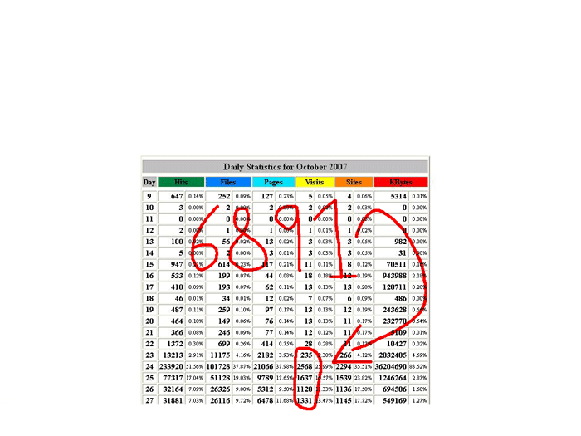

Now, take a look on all the sales I had
(see next page)…

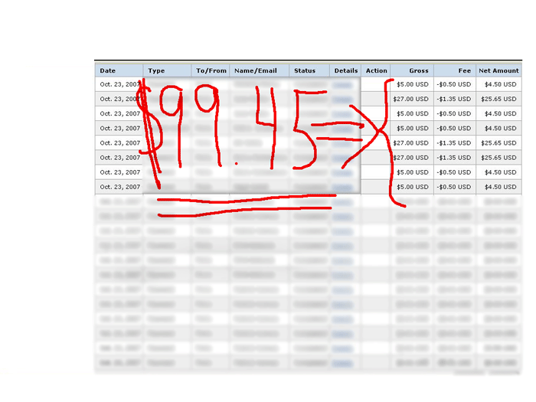

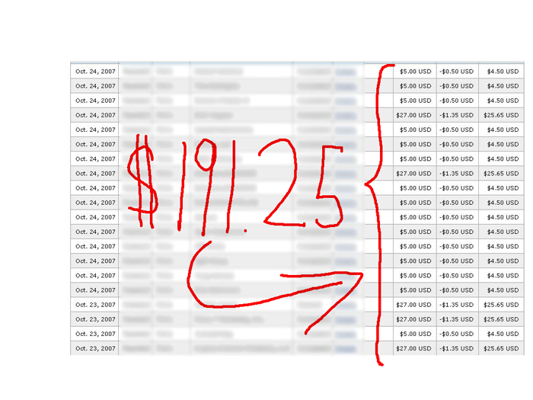
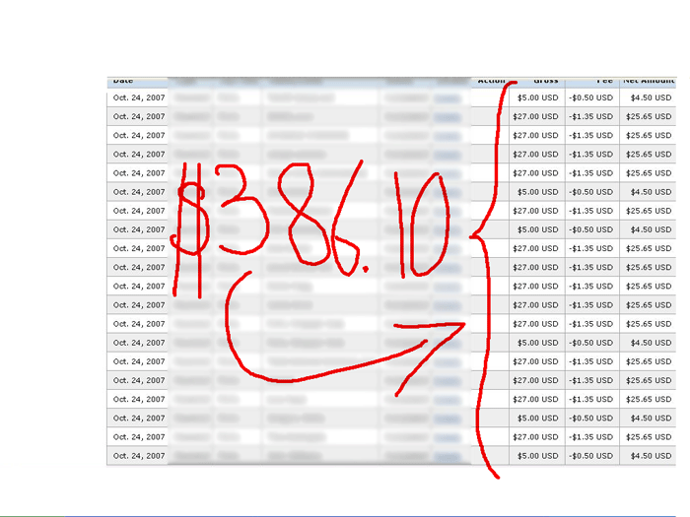
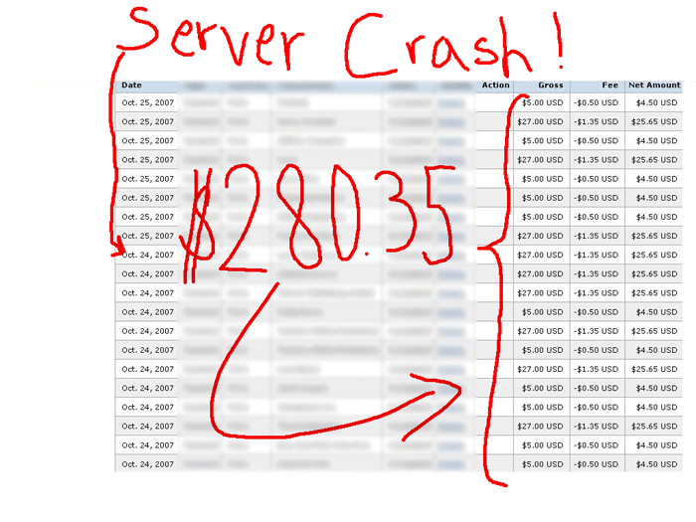

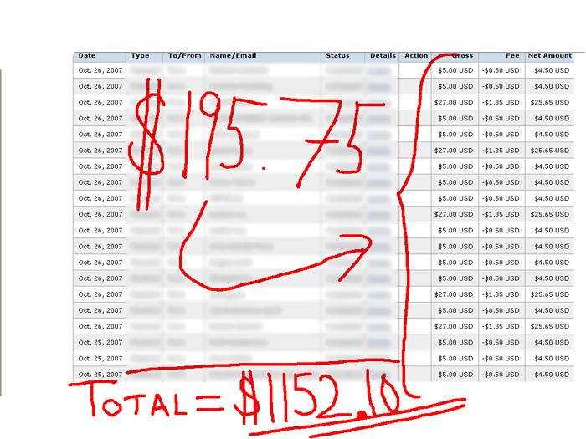

Yep, I passed my $1000 goal!...

In fact, I got to the $800 mark after the first 16 hours I think… ☺

With this, I got also a couple hundred of subscribers!

Of course, the money that started to roll in was great, but even greater was all the people subscribing to our list.

For a more detailed explanation about how to implement this I recommend Willie Crawford´s

“Really Fast Money -How To Make $1000 - $2000 In 24 Hours Or Less!”

I learned a lot from his ebook, his recommendations are worth much more than the price of what he is selling it for.

But, remember, if you don´t put all this to work, you will not get any results…

The only thing that will stop you from succeeding is to think:

“Sure, others do it, but I don´t think that “I” will be able to do this…”

I understand how you feel, and I used to think the same way before, but I learned that you can not always make everything right, just do the best, plan, and then like the famous quote from Nike says: “Just Do It”

Sometimes you will fail, and other times you will succeed, but you have to try, try and try again…

Learn from your mistakes and don´t repeat the same mistakes…

For example, one thing I learned from this is that you have to think about your webhosting server capacity,

I had such a big package of templates and at the same time thousands of visitors coming to my site that my server crashed by launch!

You maybe think… “that is a great problem to have”, and of course, I was happy with all the orders and people coming to my site,

But I know that a lot more people would have buyed…, because, I lost almost one day without being able to receive orders trying to fix the problem.

I talked to Willie Crawford, and he told me: ‘Robin I know your are in the middle of a sale, but, don’t panic’… I have to confess that I was starting to get pretty much nervous…

Anyway, I thought about his words and started to do everything one thing at a time, step by step, to fix the mess.

I managed to fix everything, and even if I had this major problem during this launch, I made $1000 in 2 days, and the sales keep coming, and also the subscribers, not with the same intensity, but hey, I should not complain!

My native language is not even English, it is Swedish and Spanish, I can not see why you can´t at least give it a try…

A great way of learning what people need and like is to go to the www.warriorforum.com/forum and take a look
at the main warrior discussion to see what people talk about.

Another section that you would like to have a look at is the warrior special offer section (WSO), take notice to the thread with the most views.

That way you are going to have an idea of what people need.

Sure, there are other forums that you can use, It is just that I have not used other forums that much, but I guess that is going to change now.

Now, when you ask people to help you promote your product, remember to be polite, the worst thing they can say is: “No”….

If you can live with that, go for it, don´t worry so much about what they are going to say, just do your best, as I said, be polite, do your best in making a quality offer.

One thing that I did was to offer my jv partners a free copy of my template package, and even if they don´t promote it they will still have a great set of templates they can use for their business.

And if you include links in your product to your business you will still make money, for example, in the templates I included links to our graphic design service, which you can find at www.ecoverworld.com, that way people would take notice and get back to us for custom made designs, and believe me, they did.

So from one intial effort I am reaping the reward now, and I have to confess that the traffic you receive this way is really great!

Now, the only thing you have to do is repeat this process and you will have “tons” of visitors, sales and subscribers to your site

If you feel this is to complicated, I can assure you it is not, don´t make it more complicated…

In resume it would look like this:

- Create a High Quality Offer that really supply the need of a certain group.
- Sell it cheap.
- Give %100 commissions to your partners.
- Make money with your back end offer, you can choose to give partners a percentage of those sales also.
- Use the warriorforum.com for your offer, but remember, if you decide to use this forum, you have to give them something special, only offered through this forum. (In my case I gave warrior members an extra big discount for life on our custom graphic design service, this big discount was not offered to other regular customers)
- Contact possible JV partners to help you promote your product.

Great Resources for your business:

A) TheInternetMarketingInnerCircle.com

B) JVCashAnytime.com

C) Warriorforum.com
D) “Really Fast Money -How To Make $1000 - $2000 In 24 Hours Or Less!”

Best Regards,
Robin Araoz Palmer

P.S. Do you need custom made designs?

Please visit http://www.ecoverworld.com

P.S. II. Would you like to make %100 in commissions on our template package giving this report away?...

Click Here to rebrand it!

Important:
Before you close this pdf I recommend you to
Watch The Following Video

abcdefghijklmnopqrstuvwxyzABCDEFGHIJKLMNOPQRSTUVWXYZ.:,;_!"'#+~*@§$%&/\´`^°|^()=?[]1234567890

abcdefghijklmnopqrstuvwxyzABCDEFGHIJKLMNOPQRSTUVWXYZ.:,;_!"'#+~*@§$%&/\´`^°|^()=?[]1234567890

abcdefghijklmnopqrstuvwxyzABCDEFGHIJKLMNOPQRSTUVWXYZ.:,;_!"'#+~*@§$%&/\´`^°|^()=?[]1234567890

abcdefghijklmnopqrstuvwxyzABCDEFGHIJKLMNOPQRSTUVWXYZ.:,;_!"'#+~*@§$%&/\´`^°|^()=?[]1234567890
abcdefghijklmnopqrstuvwxyzABCDEFGHIJKLMNOPQRSTUVWXYZ.:,;_!"'#+~*@§$%&/\´`^°|^()=?[]1234567890

